Assignment 1
HIT365 – C programming
This assignment is worth 5% of the assessment for this unit. Late submissions will not be accepted unless prior arrangements have been made.
Show all working and explanations. Remember to write sentences.
Successfully completion of tutorial exercises is worth 20% of your mark
Question 1 (30 Marks)
Fix or describe the error in each of the following pieces of code:
a)
float x = 19.23;
float xPrt = &x;
printf(“%f\n”,xPtr)

b)
int *x,y;
x=y;
Question 2 (10 Marks)

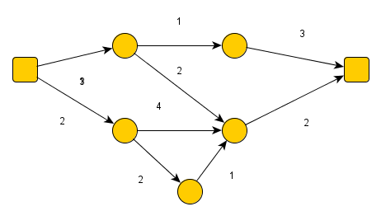
Write a matrix representation of the above digraph
Question 3 (30 Marks)
Write a function that allows you to input a graph or takes a graph as input and calculates the following
- The total number of edges
- The degree of each of the nodes (vertices) in the graph
- The minimum, maximum and total degree of the nodes in the graph
Question 4 (30 Marks)
- Calculate the answer for the graph given in questions 1
- Write another function that test the function you wrote for Question
- Call these functions from you main function to test you program.

